1.Header

Header.js:

import React from 'react';

import './Header.css';

function Header() {

  return (

    <header className="header">

      <div className="log">Express Trendy</div>

      <nav className="nav">

        <ul>

          <li><a href="/">login</a></li>

          <li><a href="/products">Productlist</a></li>

        </ul>

      </nav>

    </header>

  );

}

export default Header;

Header.Css

/\* Header.css \*/

.header {

  background-color: rgb(238, 214, 240);

  color: rgb(0, 0, 0);

  padding: 20px;

  display: flex;

  justify-content: space-between;

  align-items: center;

  font-family: Georgia, 'Times New Roman', Times, serif;

}

.log {

  font-size: 24px;

  font-weight: bold;

}

.nav ul {

  list-style: none;

  display: flex;

  font-size: 24px;

  font-family: Georgia, 'Times New Roman', Times, serif;

}

.nav ul li {

  margin-right: 20px;

}

Output:

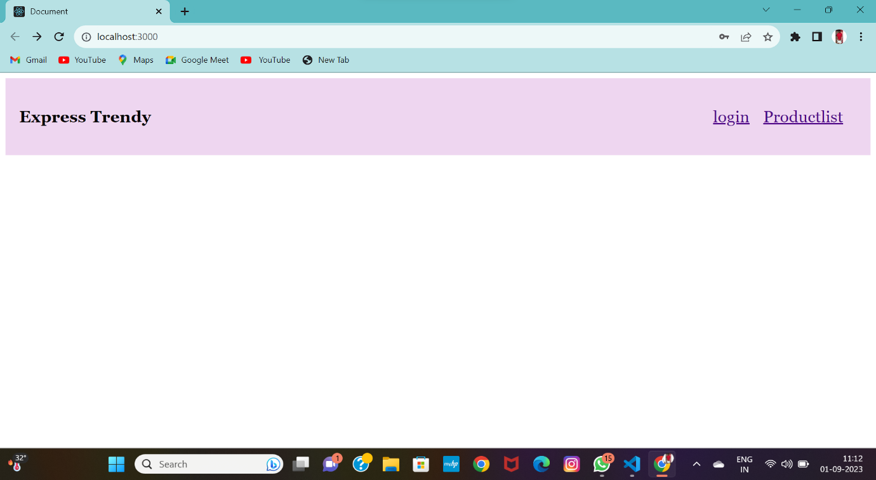

2.Footer

Footer.js:

import React from 'react'

function Foter() {

  return (

    <div>

       <footer className="footer">

      <div className="footer-content">

        <p>&copy; 2023 Your Company. All rights reserved.</p>

      </div>

    </footer>

    </div>

  )

}

export default Foter

Footer.css

.footer {

    background-color: rgb(238, 214, 240);

    color: rgb(0, 0, 0);

    padding: 20px;

    text-align: center;

  }

.footer-content{

    max-width: 8100px;

    margin: 0 auto;

}

Output:

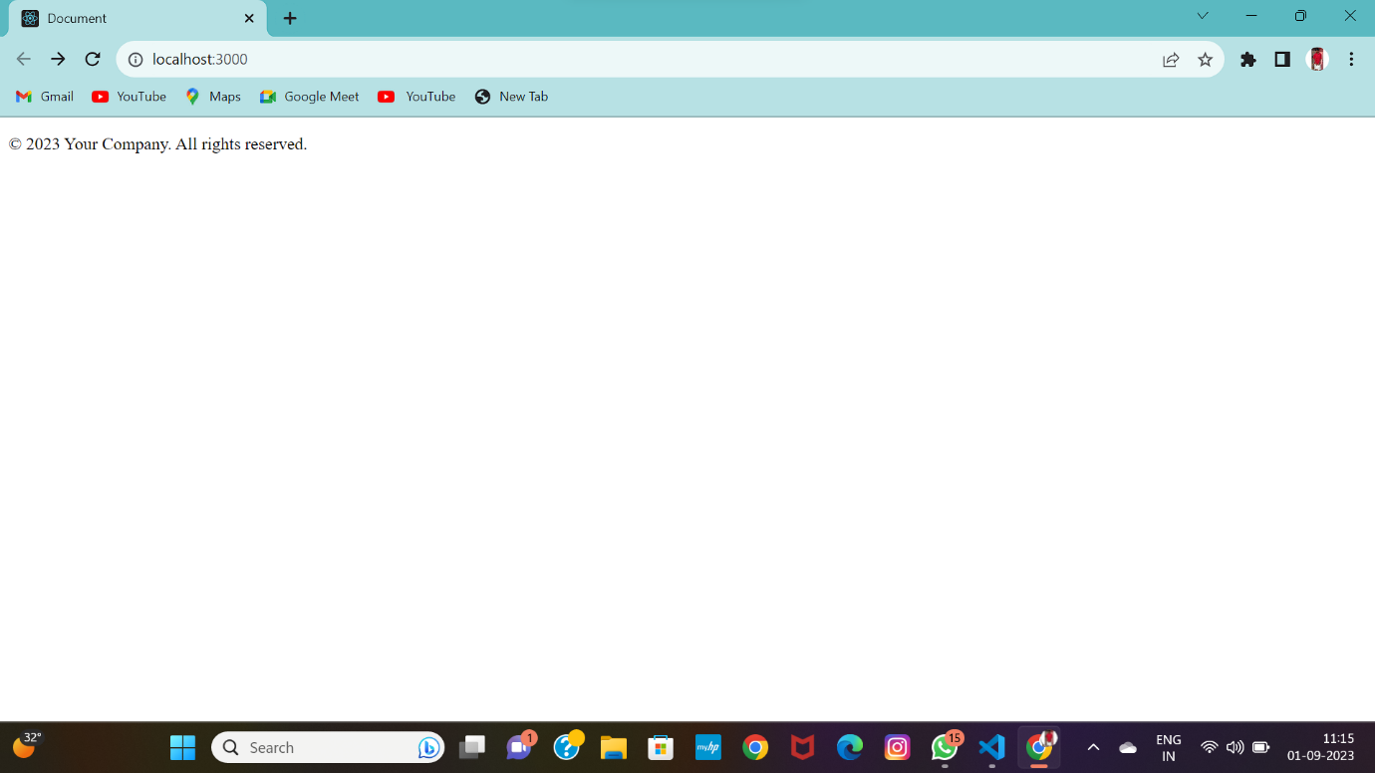

3.Login

Login.js:

import React, { useState } from 'react';

const Login = ({ onLogin }) => {

  const [username, setUsername] = useState('');

  const [password, setPassword] = useState('');

  const handleSubmit = (e) => {

    e.preventDefault();

    // You can perform login logic here

    onLogin(username);

  };

  return (

    <div className="login-form">

      <h2>Login</h2>

      <form onSubmit={handleSubmit}>

        <div>

          <label htmlFor="username">Username:</label>

          <input type="text" id="username" value={username} onChange={(e) => setUsername(e.target.value)} />

        </div>

        <div>

          <label htmlFor="password">Password:</label>

          <input type="password" id="password" value={password} onChange={(e) => setPassword(e.target.value)} />

        </div>

        <button type="submit">Login</button>

      </form>

    </div>

  );

};

export default Login;

4.ProductList

ProductList.js:

import React from 'react'

const initialProducts = [

    // Array of product objects

  ];

function Product()

   {

  return (

      <div className="app">

      <h1>E-commerce Website</h1>

      <Product products={initialProducts} />

    </div>

  )

}

export default Product